Project Design Phase
Solution Architecture

Date | 28 September 2026
Team ID | SWTID-2026-6232
Project Name | AI WeatherWise API
Maximum Marks | 4 Marks

Solution Architecture:
Solution architecture for AI WeatherWise API connects the identified weather-related problems with an appropriate technology-based solution. Its goals are to:
● Find the suitable technologies such as Node.js, Express.js, MongoDB, and Gemini AI to solve weather information and user assistance problems.
● Describe the structure and components of the AI WeatherWise API, including routes, controllers, services, database, authentication, and AI services.
● Define the features and development requirements, such as weather information, AI weather summary, recommendations, weather story/poem, and AI chatbot.
● Provide a clear technical structure for developing, managing, testing, and delivering the AI WeatherWise API solution.

Example - Solution Architecture Diagram:
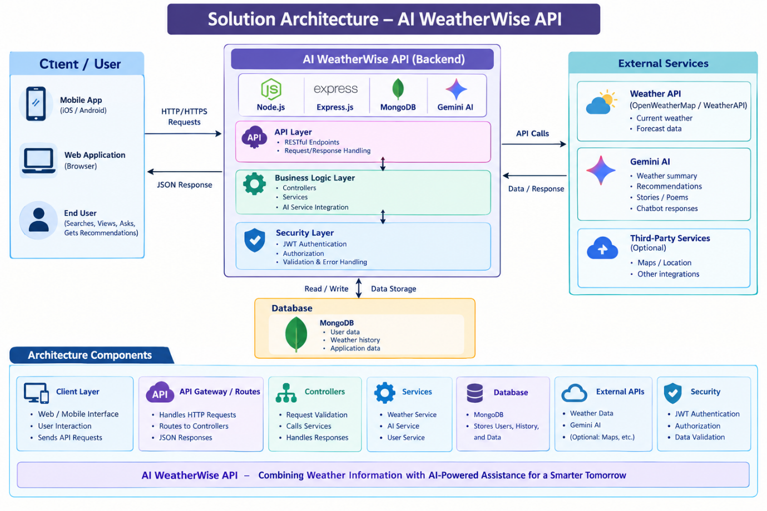

Reference: https://www.mitre.org/sites/default/files/publications/pr-17-4589-guide-creating-useful-solution-architectures.pdf?utm_source=chatgpt.com

